Appendix 1. English version of the ‘Young Spine Questionnaire’

Name______________________________ Class________________

This questionnaire is related to the spine and neck. Use only one cross (X) to answer each question. If none of the answers are suitable, place your cross by the answer that is best suited.
1. The neck is shown in the picture
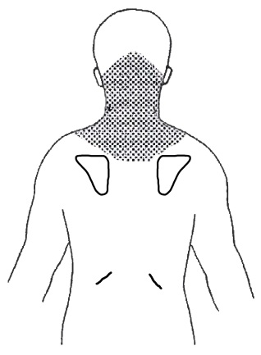
The neck
 |  |  | Person seen from behind
1a. Have you had pain in the neck? |  |  |  |  |  | Often  Once in a while  Once or twice  Never
1b. Have you had neck pain in the last week? |  |  |  |  |  | Yes  No
1c. Have you had neck pain today? |  |  |  |  |  | Yes  No
The faces below show how much something can hurt. The pain ranges from ‘No pain’ to ‘A lot of pain’.
1d. Put a cross (X) on the face which shows how much pain you have had in the neck when it was worst.
No pain |  |  |  |  |  |  |  |  | A lot of pain
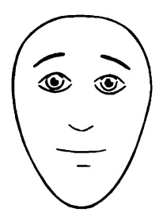 | 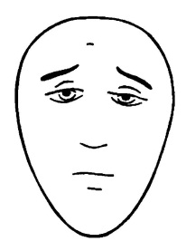 | 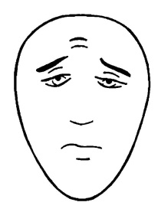 |  |  | 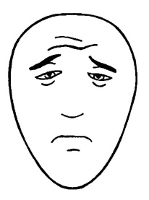 |  | 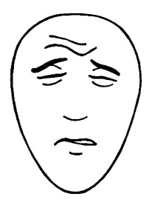 |  | 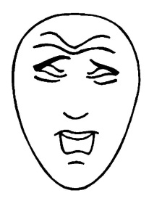

2. The middle of the back is shown in the picture.
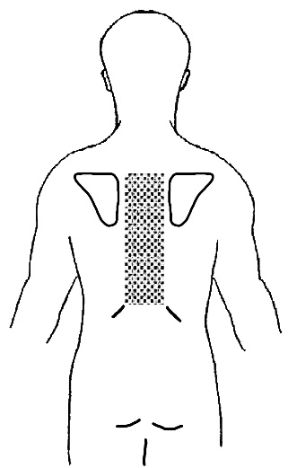
Middle of the back
 |  | Person seen from behind
2a. Have you had pain in the middle of the back? |  |  |  | Often  Once in a while  Once or twice  Never
2b. Have you had pain in the middle of the back in the last week? |  |  |  | Yes  No
2c. Have you had pain in the middle of the back today? |  |  |  | Yes  No
2d. Put a cross (X) on the face which shows how much pain you have had in the middle of the back when it was worst.
No pain |  |  |  |  |  | A lot of pain

3. The lower back is shown in the picture.
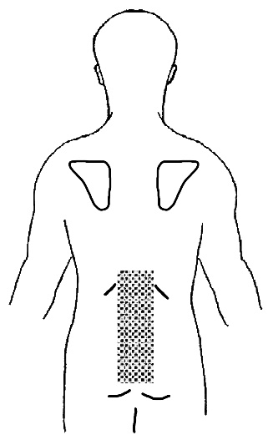
The lower back
 |  |  | Person seen from behind
3a. Have you had pain in the lower back? |  |  |  |  | Often  Once in a while  Once or twice  Never
3b. Have you had pain in the lower back in the last week? |  |  |  |  | Yes  No
3c. Have you had pain in the lower back today? |  |  |  |  | Yes  No
3d. Put a cross (X) on the face which shows how much pain you have had in the lower back when it was worst.
No pain |  |  |  |  |  |  |  | A lot of pain

4. School, recreation and treatment
4a. Have you stayed home from school because of neck or back pain? |  | Often  Once in a while  Once or twice  Never
4b. Has neck or back pain sometimes stopped you from doing sports? |  | Often  Once in a while  Once or twice  Never
4c. Have you been to a doctor, chiropractor or physiotherapist because of neck or back pain? |  | Often  Once in a while  Once or twice  Never
5. The family
5a Has your father or stepfather ever had back or neck pain? |  | Yes  No
5b. If he has, has it kept him home from work? |  | Often  Once in a while  Never
5c Has your mother or stepmother ever had back or neck pain? |  | Yes  No
5d. If she has, has it kept her home from work? |  | Often  Once in a while  Never

