**Supplementary Appendix**

**eFigure 1. Trends in Self-Reported Prediabetes by Age (Panel A), Body Mass Index Category (Panel B), and Race/Ethnicity Group (Panel C)**

[A]

/Users/carolineliu/Desktop/age.pdf

[B]

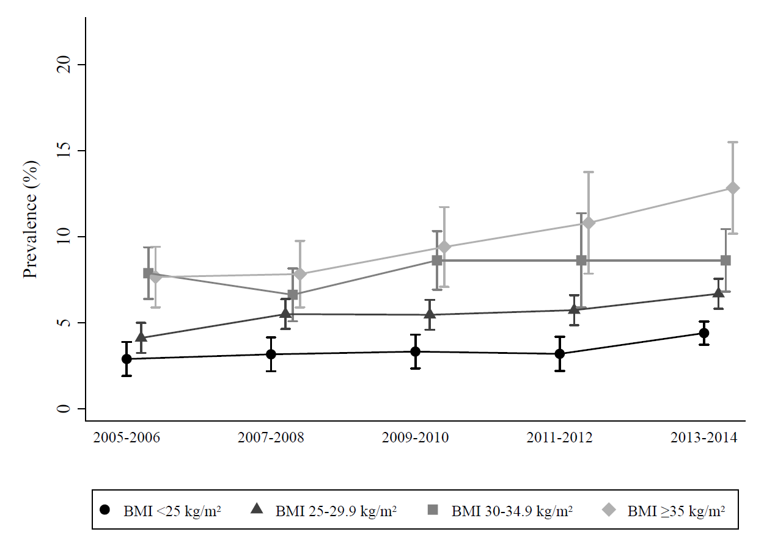

[C]

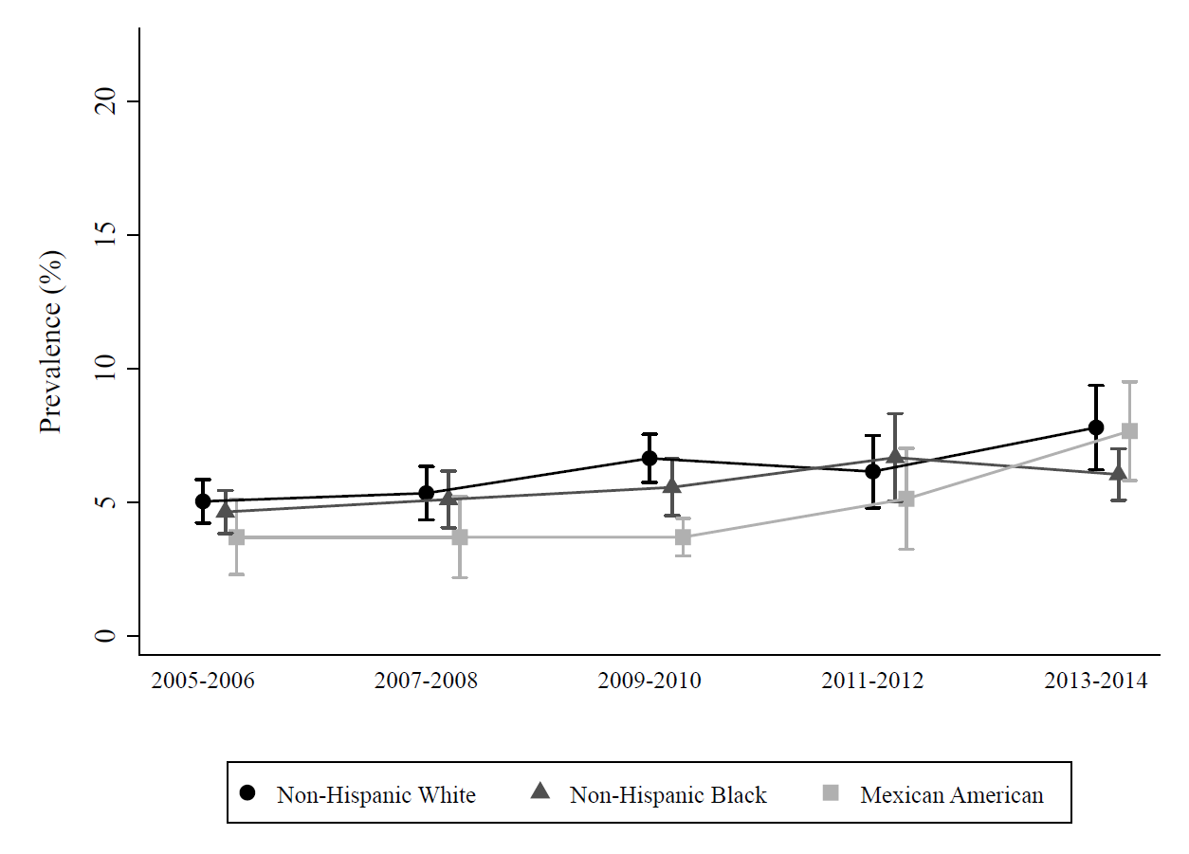

**eTable 1. Demographic and Clinical Characteristics of U.S. Adults with Self-Reported Prediabetes by Race/Ethnicity, NHANES 2005-2014**

|  |  |  |  |  |  |
| --- | --- | --- | --- | --- | --- |
|  | Self-Reported Prediabetes | | |  | |
|  | Non-Hispanic White  Mean or % (SE) | Non-Hispanic Black  Mean or % (SE) | Mexican American  Mean or % (SE) | | *P*-value |
| N | 792 | 340 | 210 | |  |
| Mean age (years) | 56.5 (0.5) | 51.1 (1.0) | 46.7 (1.0) | | <0.001 |
| Age category, % |  |  |  | |  |
| 20-39 years | 13.3 (1.3) | 22.6 (3.1) | 32.1 (3.2) | |  |
| 40-64 | 55.5 (2.1) | 59.5 (3.0) | 56.0 (3.0) | | <0.001 |
| ≥65 years | 31.3 (1.7) | 17.9 (2.2) | 11.9 (2.0) | |  |
| Male Sex, % | 46.9 (2.2) | 39.1 (2.9) | 49.2 (3.4) | | 0.03 |
| Education, % |  |  |  | |  |
| Greater than high school | 62.6 (2.2) | 55.7 (3.6) | 31.1 (3.3) | |  |
| High school | 24.9 (1.9) | 24.2 (2.8) | 19.1 (3.2) | | <0.001 |
| Less than high school | 12.6 (1.5) | 20.1 (3.0) | 46.8 (3.0) | |  |
| Mean BMI (kg/m2) | 31.0 (0.3) | 34.0 (0.5) | 32.7 (0.5) | | 0.05 |
| BMI categories, % |  |  |  | |  |
| <25 kg/m2 | 17.5 (1.3) | 13.0 (2.1) | 10.4 (2.1) | |  |
| 25-29 kg/m2 | 32.5 (1.9) | 22.2 (2.4) | 26.8 (2.8) | | <0.001 |
| 30-34 kg/m2 | 25.6 (1.8) | 25.4 (2.6) | 32.3 (3.6) | |  |
| ≥35 kg/m2 | 24.5 (1.7) | 39.4 (3.0) | 30.5 (2.7) | |  |
| Mean waist circumference (cm) | 105.4 (0.6) | 107.3 (1.1) | 105.0 (1.1) | | 0.19 |
| Waist circumference category, % |  |  |  | |  |
| Low-risk | 30.6 (1.4) | 30.1 (3.1) | 26.0 (3.2) | | 0.49 |
| High-risk | 69.4 (1.4) | 69.9 (3.1) | 74.0 (3.2) | |
| Mean HbA1c | 5.65 (0.02) | 5.84 (0.05) | 5.87 (0.1) | | <0.001 |
| HbA1c Categories, % |  |  |  | |  |
| <5.7%-points | 59.2 (2.0) | 44.4 (2.9) | 61.0 (3.5) | |  |
| 5.7-6.4%-points | 33.8 (2.0) | 44.5 (2.8) | 25.7 (2.7) | | 0.003 |
| ≥6.5%-points | 7.1 (1.1) | 11.0 (1.8) | 13.4 (2.3) | |  |
| Mean fasting glucose (mg/dL) | 108.2 (1.0) | 108.1 (2.3) | 110.1 (2.5) | | 0.80 |
| Fasting glucose categories, % |  |  |  | |  |
| <100 mg/dL | 37.1 (3.1) | 40.0 (4.7) | 40.7 (6.3) | |  |
| 100-125 mg/dL | 47.7 (3.0) | 47.6 (4.8) | 44.5 (6.0) | | 0.90 |
| ≥126 mg/dL | 15.2 (1.9) | 12.4 (2.8) | 14.8 (3.4) | |  |
| Metformin use, % | 5.7 (1.0) | 6.5 (1.6) | 6.4 (1.9) | | 0.87 |
| Family history of diabetes, % | 47.0 (2.1) | 60.8 (2.5) | 62.4 (3.0) | | <0.001 |
| History of cardiovascular disease, % | 12.7 (1.4) | 11.2 (1.6) | 6.0 (1.4) | | 0.02 |
| Predicted ASCVD 10-year risk, % |  |  |  | |  |
| <7.5% | 60.6 (3.5) | 61.4 (4.0) | 81.8 (3.6) | | <0.001 |
| ≥7.5% | 39.4 (3.5) | 38.6 (4.0) | 18.2 (3.6) | |
| Hypertension, % | 55.3 (2.4) | 58.8 (3.5) | 32.7 (4.0) | | 0.003 |
| Hypercholesterolemia, % | 44.3 (3.5) | 37.8 (4.2) | 21.8 (3.8) | | 0.003 |
| Smoking Category, % |  |  |  | |  |
| Never | 45.2 (2.3) | 60.1 (2.7) | 58.6 (4.2) | |  |
| Former | 39.6 (2.2) | 16.9 (2.0) | 30.5 (3.6) | | <0.001 |
| Current | 15.2 (1.5) | 23.0 (2.2) | 10.9 (2.2) | |  |
| Tried losing weight in the past year, % | 51.5 (2.2) | 50.3 (3.1) | 53.6 (4.3) | | 0.85 |
| Physical Activity |  |  |  | |  |
| ≥600 METS/week*, % | 57.8 (2.5) | 53.6 (2.8) | 54.5 (4.1) | | 0.51 |
| Limitations/barriers to activity, % | 9.0 (1.1) | 18.4 (2.2) | 7.3 (2.0) | | <0.001 |

Abbreviations: ASCVD, Atherosclerotic cardiovascular disease; BMI, body mass index; HbA1c, Hemoglobin A1c; METS, metabolic equivalents; SE, standard error

* Beginning in 2007, NCHS used the World Health Organization Global Physical Activity Questionnaire