Supplementary files
Do visual pain trajectories reflect the actual course of low back pain? A longitudinal cohort study
Table of Contents
Supplementary file 1 1
Supplementary file 2 4
Supplementary file 3 6
Supplementary file 4 7
Supplementary file 5 8
Supplementary file 6 10

Supplementary file 1
Distribution of those with more than 20 weeks of pain and those with fewer pain weeks
Visuel pain trajectory | > 20 weeks with pain, n (%) | ≤ 20 weeks with pain, n (%)
Unrecognized | 10 (13) | 68 (87)
Single episode/Recovered | 13 (5) | 227 (95)
Episodic | 15 (17) | 72 (83)
Fluctuating minor | 70 (59) | 49 (41)
Stable minor | 18 (41) | 26 (59)
Fluctuating intermediate | 88 (79) | 24 (21)
Fluctuating severe | 29 (91) | 3 (9)
Persistent severe | 6 (86) | 1 (14)

The joint distribution of the variation on top of a trend and of average pain intensity for each participant
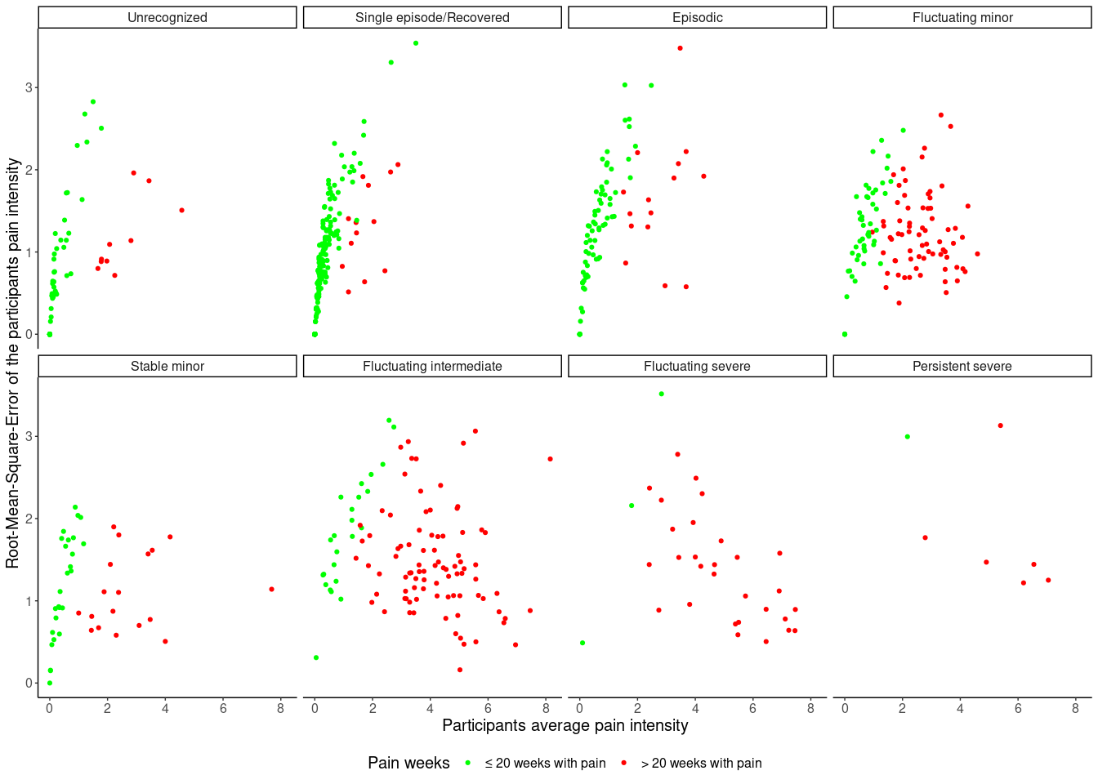

Supplementary file 2
Association between baseline characteristics and non-response
Parameter | Total sample, N | Non-response, n | OR¹ | 95% CI¹ | p-value
Back pain (0-10) | 1,230 | 528 | 1.01 | 0.96, 1.07 | 0.7
Leg pain (0-10) | 1,234 | 525 | 1.01 | 0.97, 1.05 | 0.5
Disability (0-10) | 1,253 | 538 | 1.00 | 1.00, 1.01 | 0.6
The STarT Back Screening Tool | 1,257 | 541
Low risk |  |  | — | —
Moderate risk |  |  | 1.23 | 0.96, 1.59 | 0.11
High risk |  |  | 1.69 | 1.26, 2.27 | <0.001
Back beliefs questionnaire (9-45) | 1,250 | 535 | 0.96 | 0.94, 0.98 | <0.001
Current episode duration | 1,256 | 541
Short |  |  | — | —
Medium |  |  | 0.96 | 0.66, 1.39 | 0.8
Long |  |  | 1.37 | 1.02, 1.84 | 0.039
Work ability index (0-10) | 822 | 275 | 0.97 | 0.92, 1.04 | 0.4
¹OR = Odds Ratio, CI = Confidence Interval
Note that the OR are different across scales, OR = Odds Ratio, CI = Confidence Interval

The distribution of visual pain trajectories for those with complete and incomplete data
Visuel pain trajectory | Non-response, N = 34 | Responder, N = 719
Unrecognized | 5 (15%) | 78 (11%)
Single episode/Recovered | 9 (26%) | 240 (33%)
Episodic | 3 (8.8%) | 87 (12%)
Fluctuating minor | 8 (24%) | 119 (17%)
Stable minor | 4 (12%) | 44 (6.1%)
Fluctuating intermediate | 5 (15%) | 112 (16%)
Fluctuating severe | 0 (0%) | 32 (4.5%)
Stable severe | 0 (0%) | 7 (1.0%)

Supplementary file 3
The average pain intensity and 10-90th percentile range for each week stratified by the self-reported visual pain trajectory at week 52
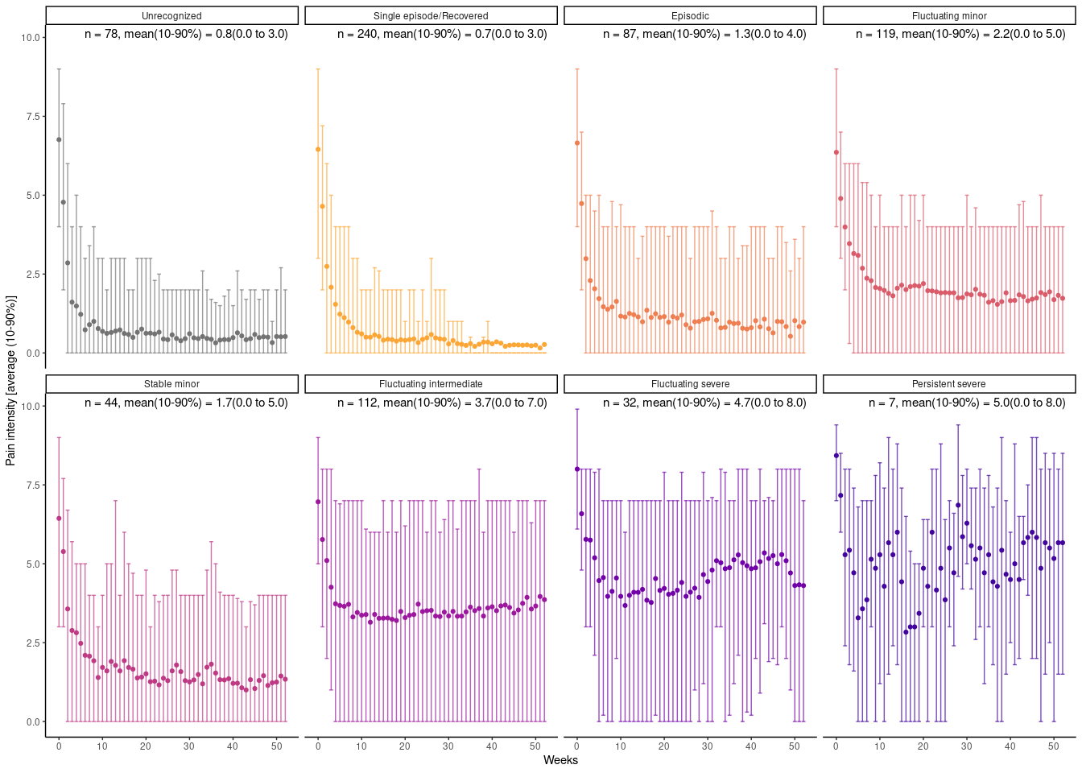

Supplementary file 4
The distribution of number of flare-ups (looking back 4 weeks and increases of 3 pain levels) stratified by their self-reported visual pain trajectories at week 52
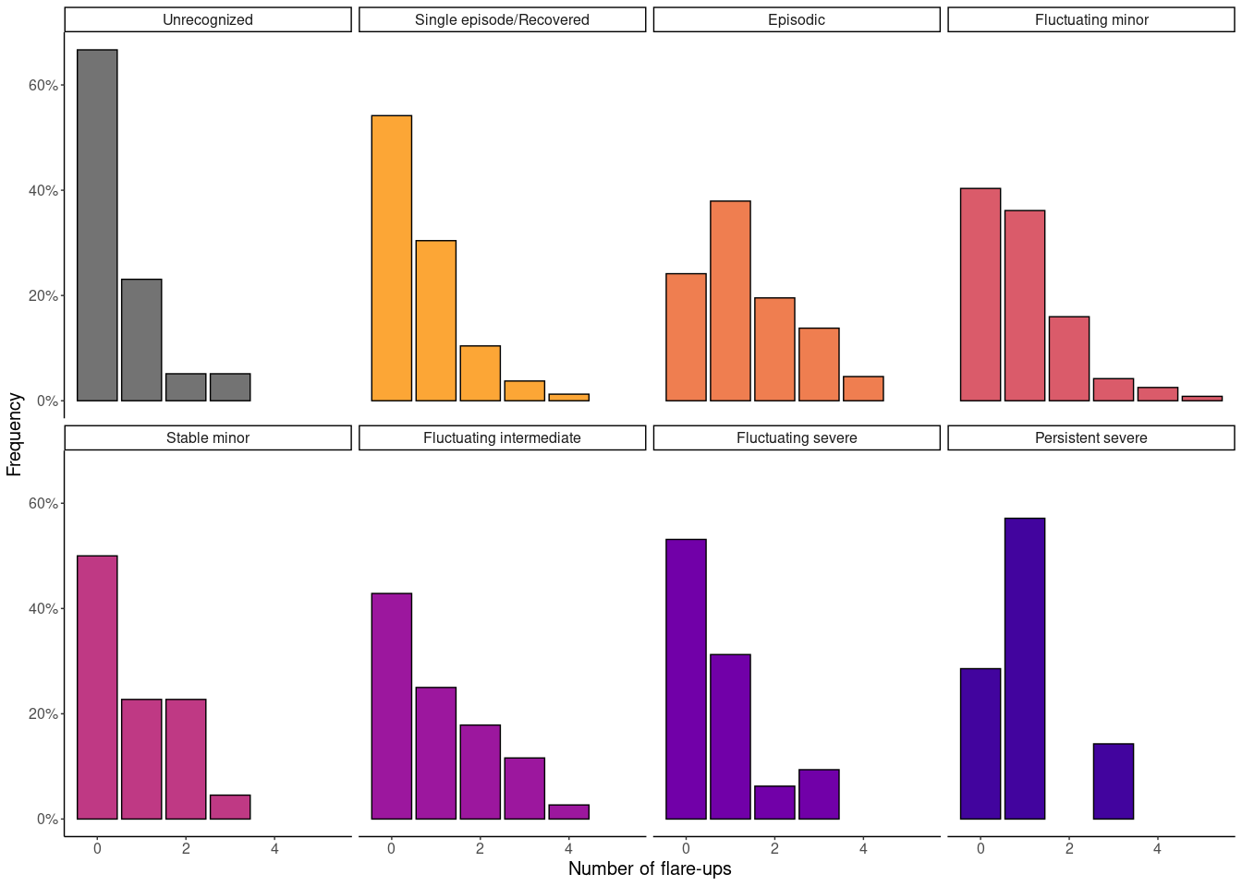

Supplementary file 5
The distribution of pain intensity and frequency for week 40 - 52 per visual pain trajectory class
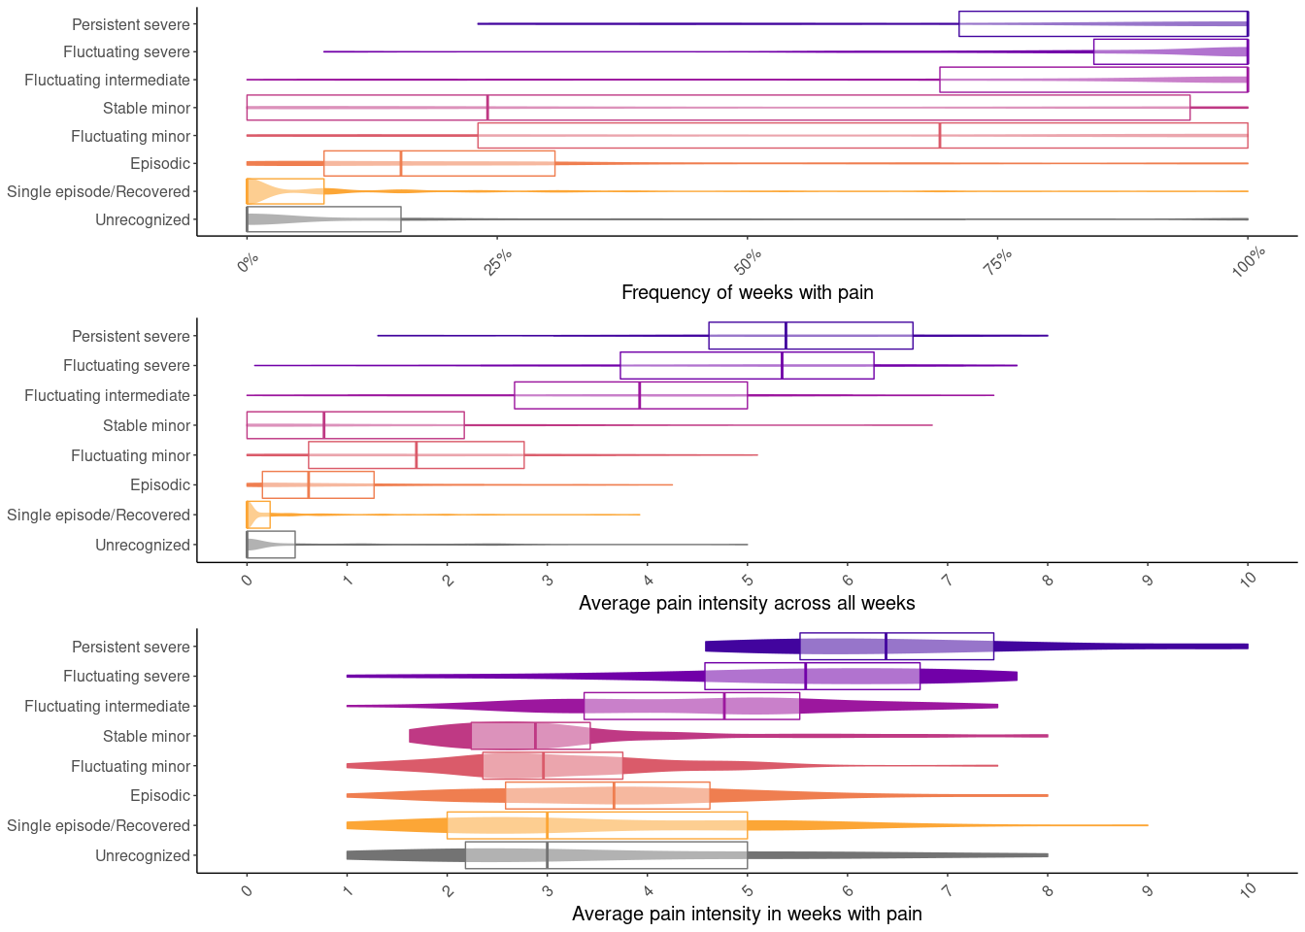

The joint distribution of the variation on top of an intensity trend for each participant in week 40 - 52
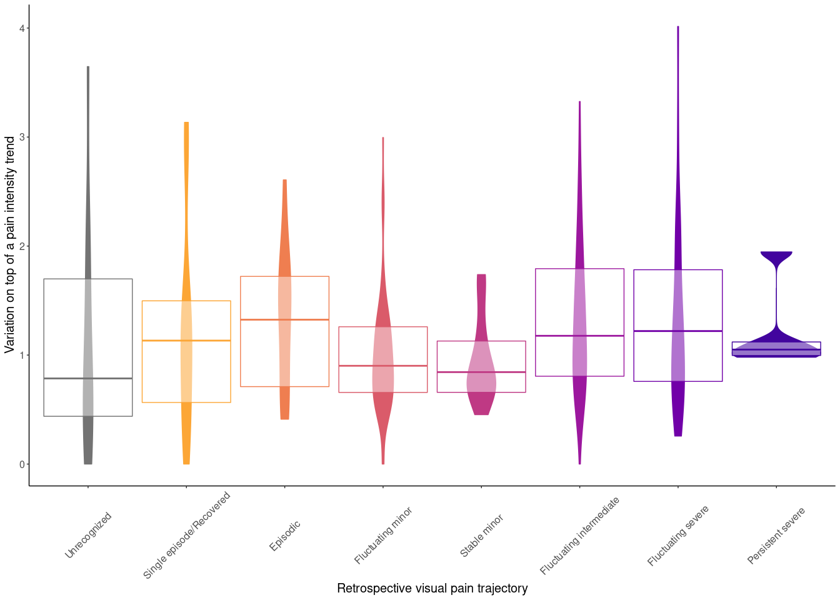

Supplementary file 6
The correlation between pain frequency and pain intensity
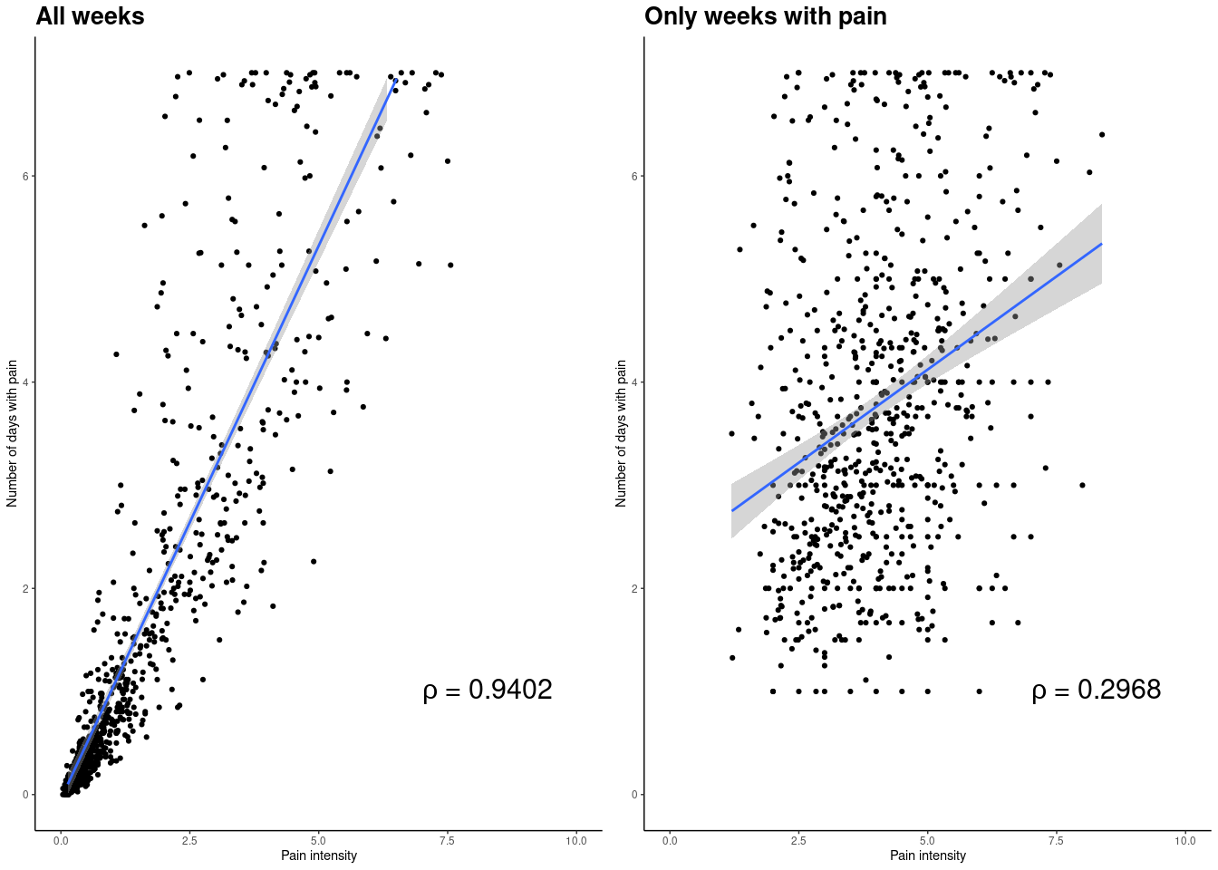
Correlation coefficients were calculated using Spearman’s rank correlation coefficient

The mean number of days with pain and 10-90th percentile range for each week by the self-reported trajectory at week 52
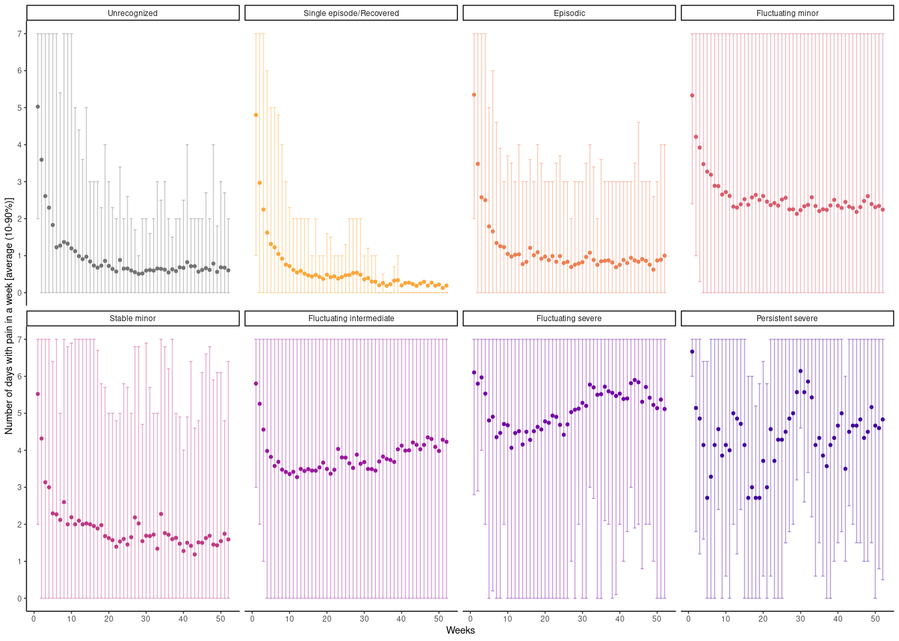

The distribution of pain frequency per visual pain trajectory class
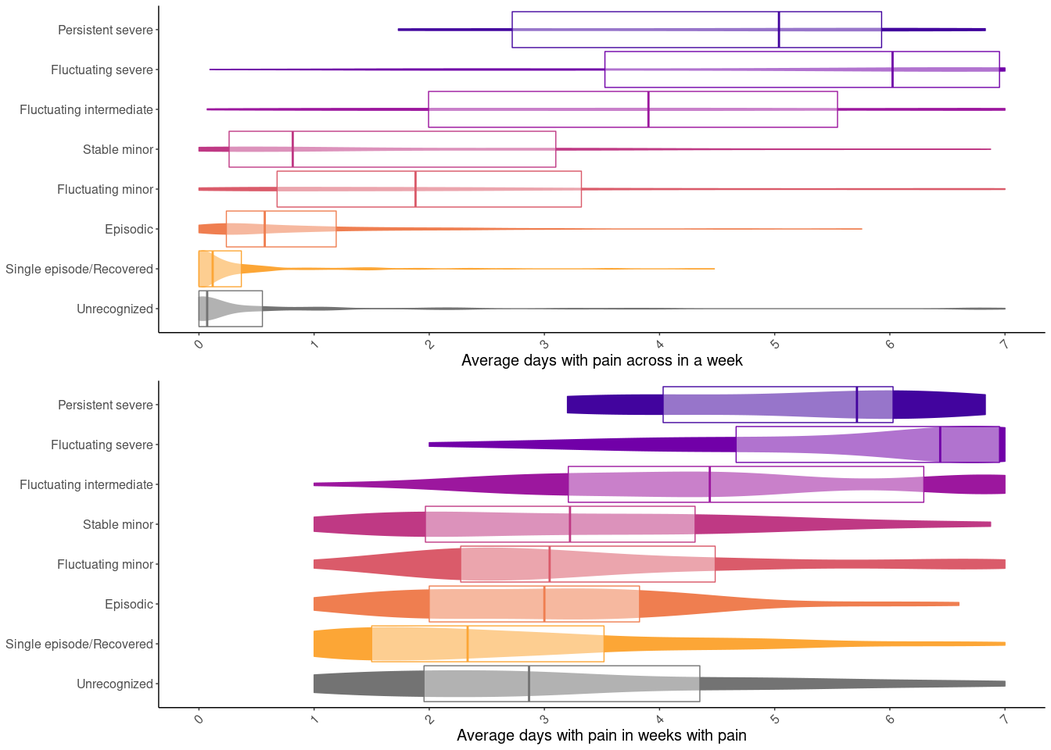

The joint distribution of the variation on top of a trend (frequency) and of average pain intensity for each participant
