Supplementary material
Selecting a dietary supplement with appropriate dosing for six key nutrients in pregnancy
Katherine A Sauder, PhD, G Lance Couzens, BS, Regan L Bailey, PhD, MPH; Christine W Hockett, PhD, Karen M Switkowski, PhD, MPH, Kristen Lyall, ScD, Jean M Kerver, PhD, RD, Dana Dabelea, MD, PhD, Luis E Maldonado, PhD, Thomas G O’Connor, PhD, Sean CL Deoni, PhD, Deborah H Glueck, PhD, Diane J Catellier, PhD, on behalf of program collaborators for Environmental influences on Child Health Outcomes

Content | Description | Page
Table 1 | Cohort characteristics and data collection methods | 2
Figure 1 | Distribution of usual intake of target nutrients during pregnancy among ECHO pregnant participants (n=2,450) from food sources only and the expected distribution with supplementation at the minimum target dose | 3
Figure 2 | Reference card for evaluating dietary supplements for pregnancy. | 7
Figure 3 | Selection diagram of dietary supplement products indexed by the National Institutes of Health Dietary Supplement Label Database (as of December 13, 2022) | 8
Figure 4 | Percent of dietary supplements in the NIH Dietary Supplement Label Database with zero, low, target, or high doses of key nutrients relative to recommendations for pregnancy | 9
Figure 5 | Percent of prenatal dietary supplements in the NIH Dietary Supplement Label Database with zero, low, target, or high doses of key nutrients relative to recommendations for pregnancy | 9
Table 2 | Nutrient content of highest ranked dietary supplements that are no longer on the market with the same formulation as recorded in the Dietary Supplement Label Database (as of December 13, 2022) | 10
Table 5 | Nutrient content of dietary supplements containing target levels of 5-6 key nutrients. | 11
References |  | 15

Supplementary Table 1. Cohort characteristics and data collection methods (n=2,450 participants total)
Cohort name  Recruitment area  (years of data collection) | Recall method | Gestational range of dietary assessment | Nutrient database | Participants (n) | Recalls (n)
Healthy Start¹  Aurora, CO  (2009-2014) | Automated Self-Administered 24-hour recall² | 6-40 weeks | Food and Nutrient Database for Dietary Studies | 1,363 | 3,949
MADRES³  Los Angeles, CA  (2015-2019) | Automated Self-Administered 24-hour recall² | 28-38 weeks | Food and Nutrient Database for Dietary Studies | 512 | 989
MARCH⁴  Michigan (statewide)  (2018-2020) | Automated Self-Administered 24-hour recall² | 15-35 weeks | Food and Nutrient Database for Dietary Studies | 140 | 254
MINNIE  Aurora, CO  (2015-2017) | Automated Self-Administered 24-hour recall² | 22-38 weeks | Food and Nutrient Database for Dietary Studies | 104 | 189
Rochester⁵  Rochester, NY  (2015-2019) | Interviewer-administered USDA Automated Multiple Pass Method⁶ | 16-39 weeks | Nutrition Data System for Research | 263 | 526
Safe Passage⁷  Sioux Falls and Rapid City, SD  (2007-2015) | Interviewer-administered USDA Automated Multiple Pass Method⁶ | 20-40 weeks | Nutrition Data System for Research | 68 | 199

Supplementary Figure 1. Distribution of usual intake of target nutrients during pregnancy among ECHO pregnant participants (n=2,450) from food sources only (left column) and the expected distribution with supplementation at the minimum target dose (right column). Percentiles of usual intake were obtained with the National Cancer Institute measurement error method and the probability approach.⁸
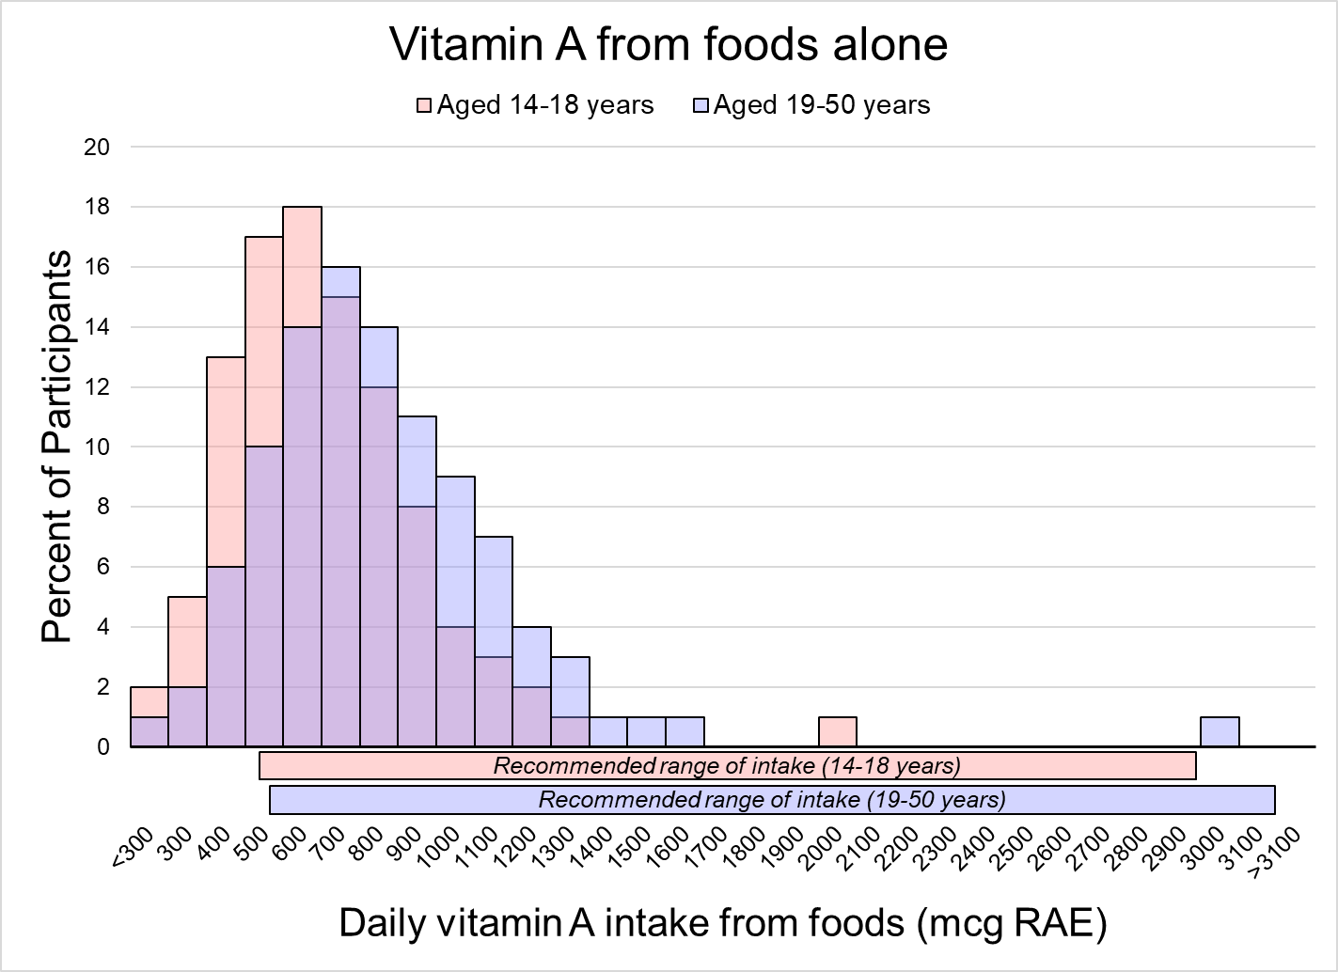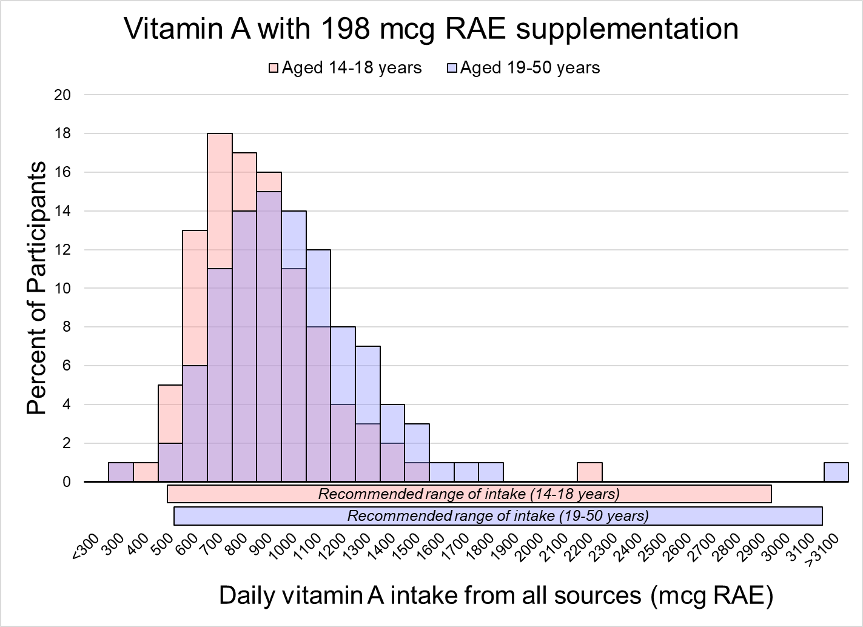
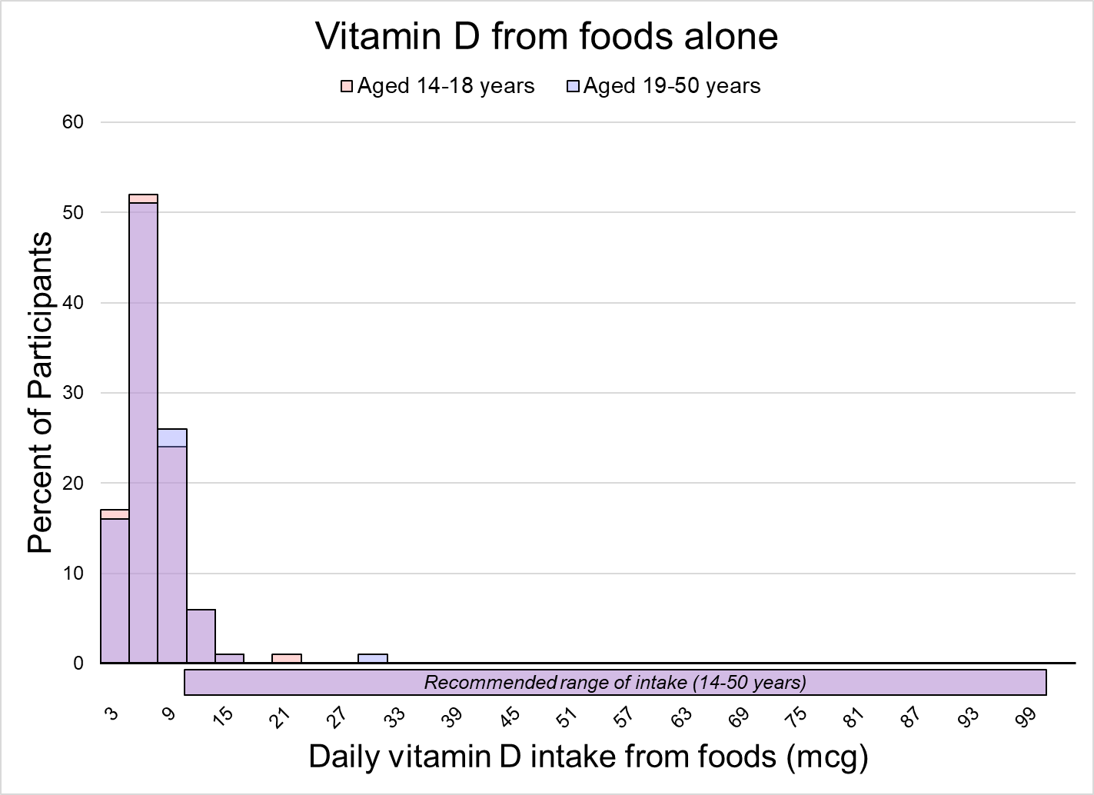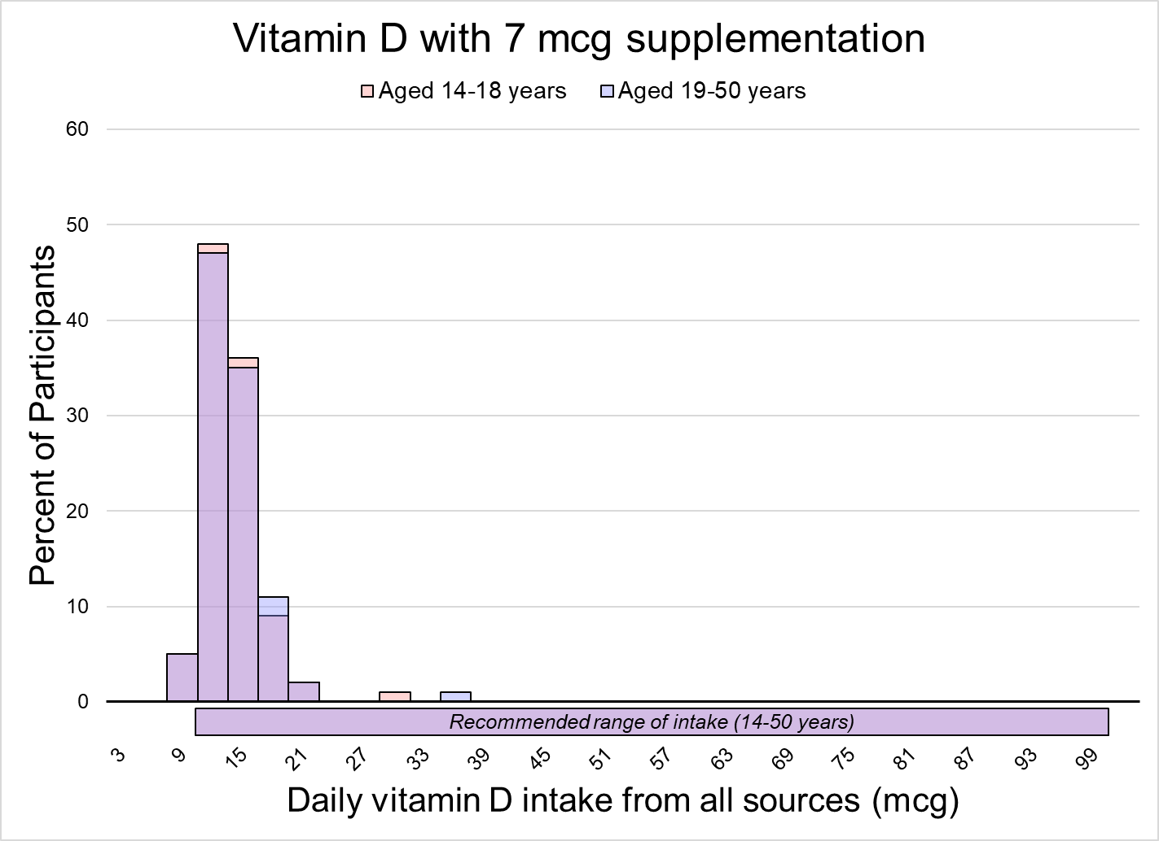
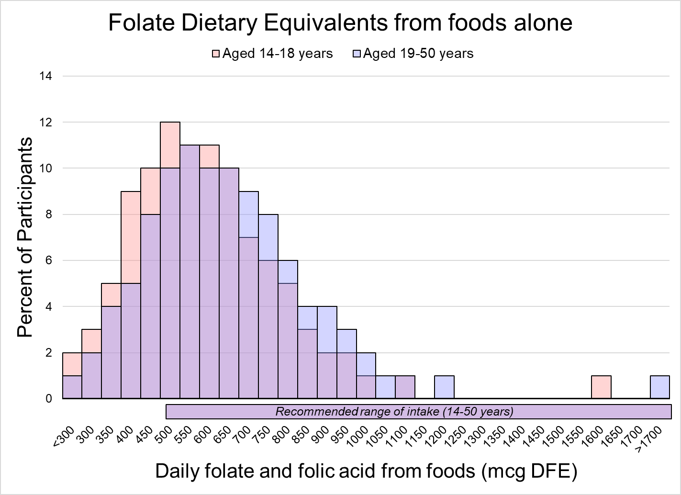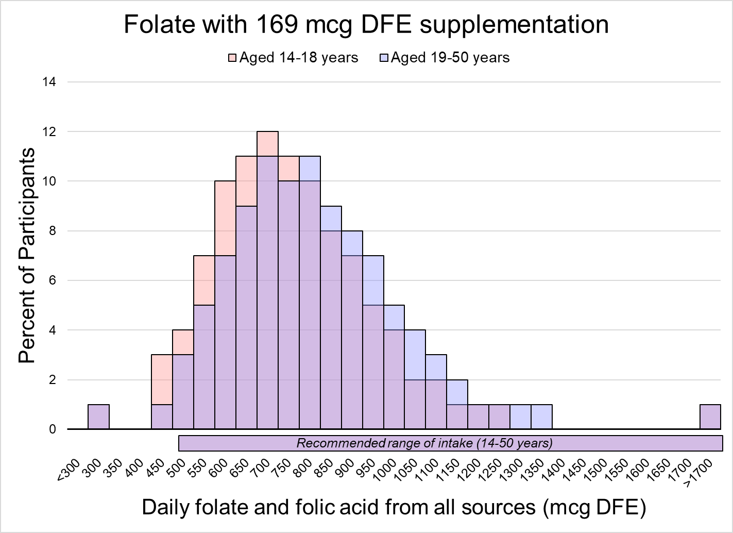

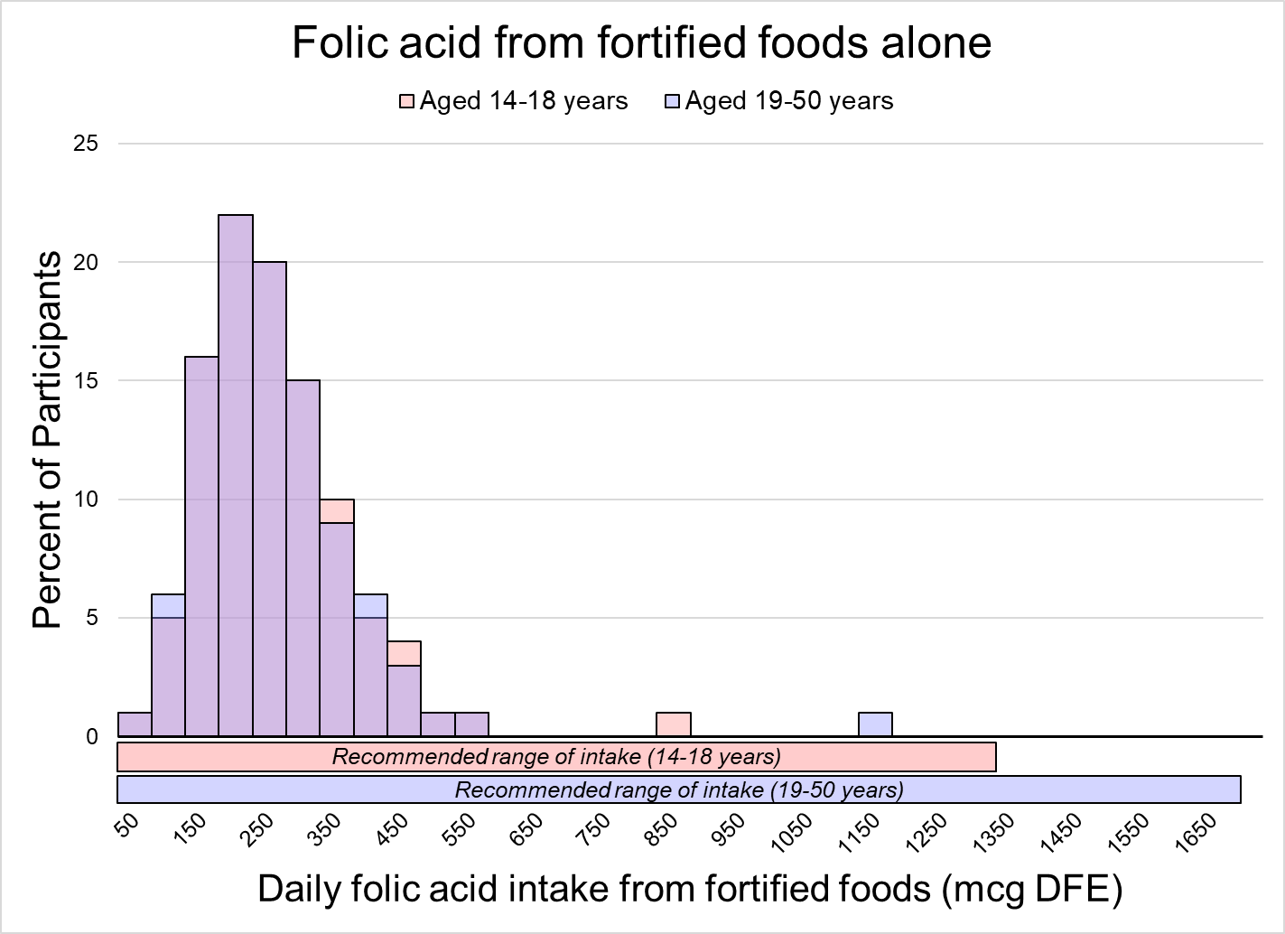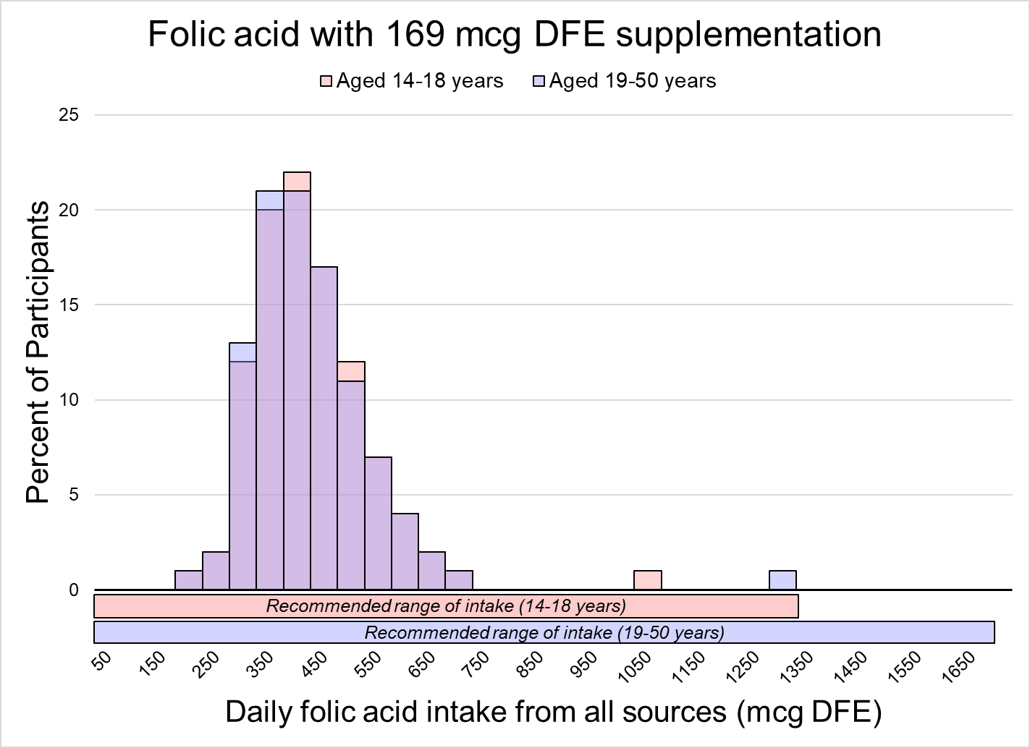
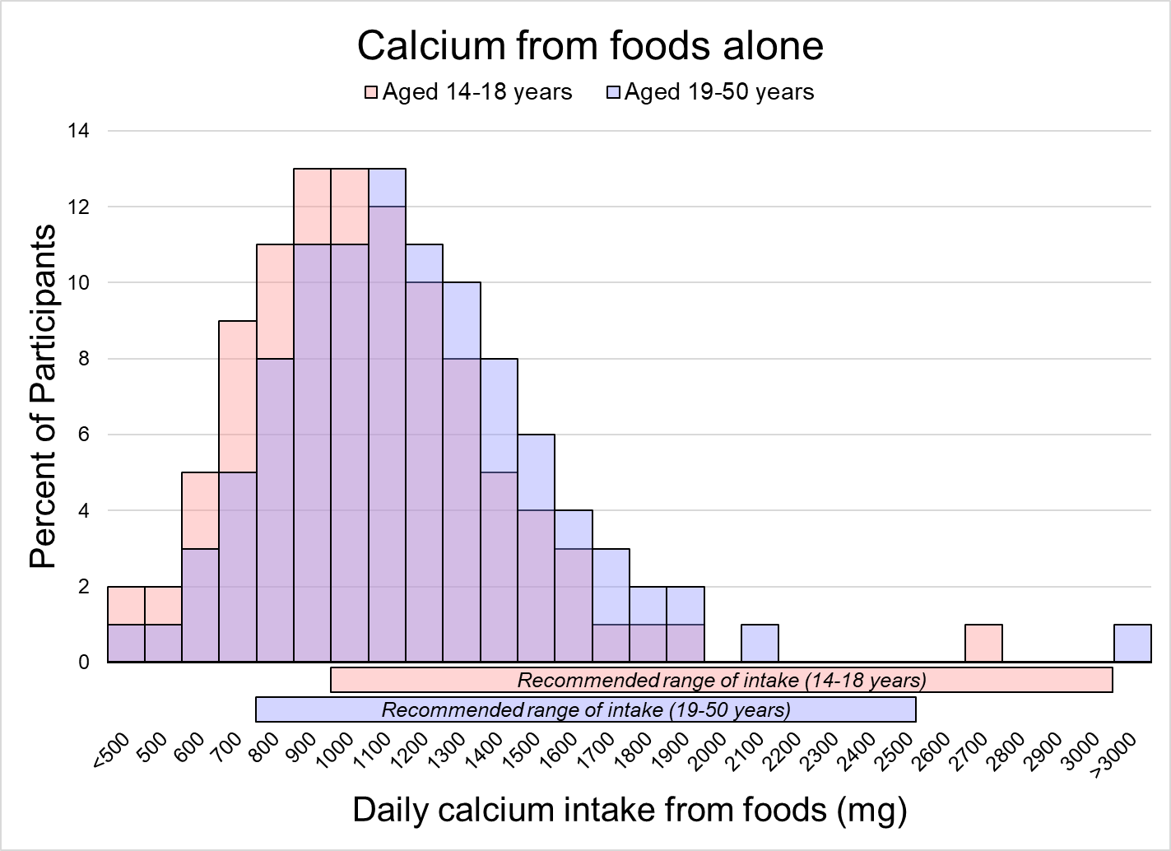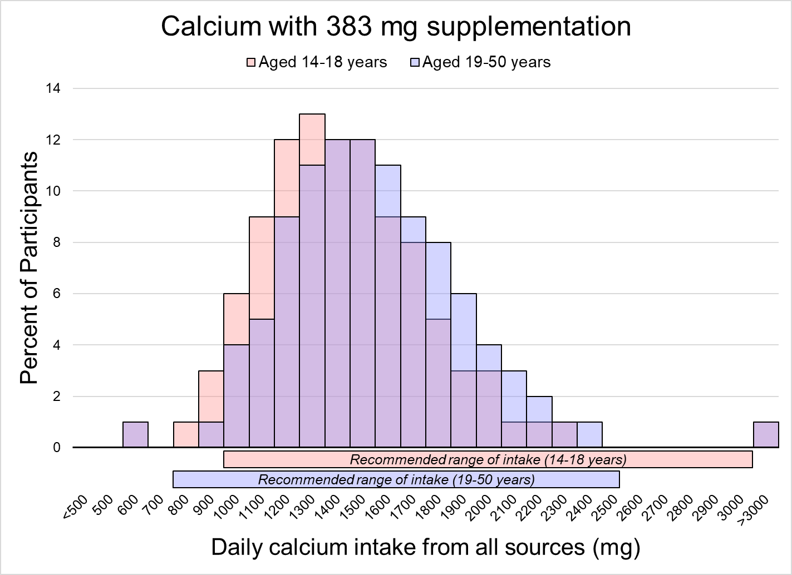

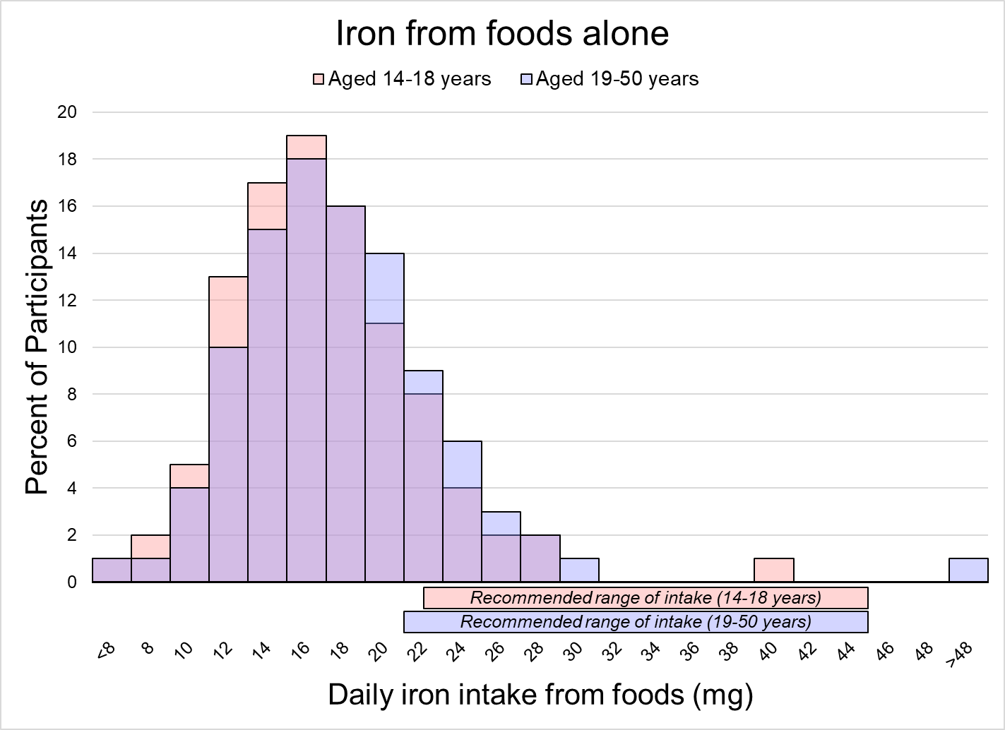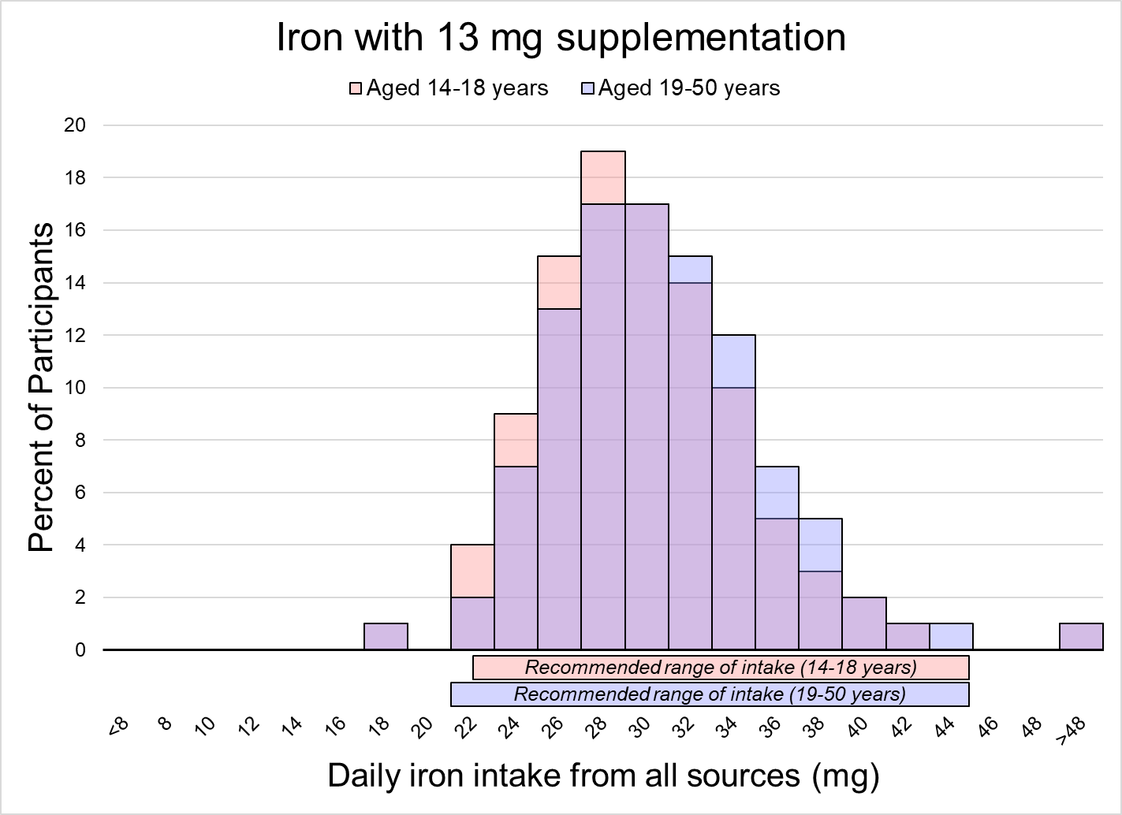

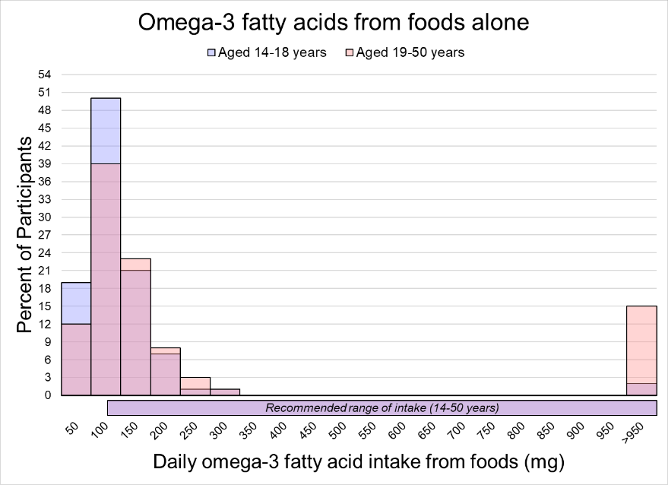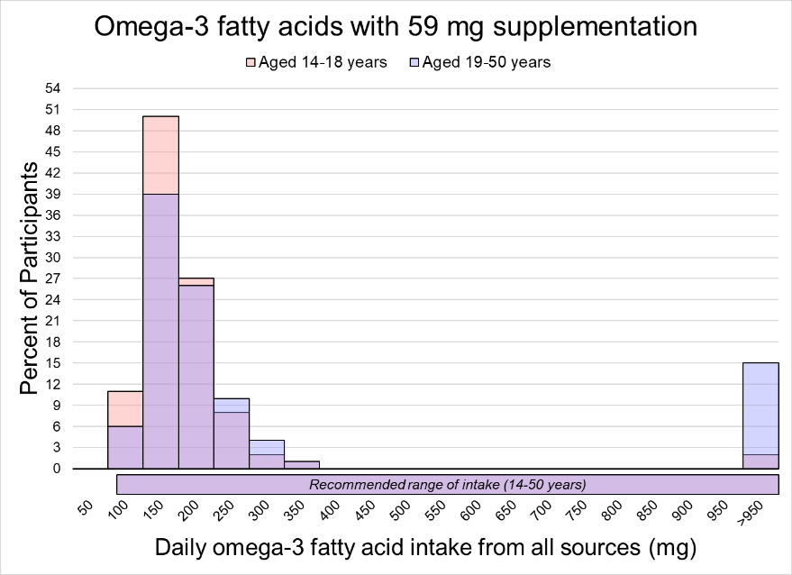

Supplementary Figure 2.
Reference card for evaluating dietary supplements for pregnancy. Supplements containing nutrients in these ranges likely reduce risk of inadequate intake to <10% and risk of excessive intake to <10% among the pregnant population aged 14-50 years.
Nutrient | Units | Lower Limit | Upper Limit
Vitamin A | (mcg RAE) | 198 | -
 | (mg RAE) | 0.2
 | (IU) | 661 | -
Retinol | (mcg RAE) | - | 2063
 | (mg RAE) | - | 2.1
 | (IU) | - | 6875
Vitamin D | (mcg) | 7 | 91
 | (mg) | 0.007 | 0.09
 | (g) | 0.000007 | 0.00009
 | (IU) | 298 | 3659
Folic Acid | (mcg DFE) | 169 | 720
 | (mcg) | 99 | 424
 | (mg DFE) | 0.17 | 0.72
 | (mg) | 0.10 | 0.42
Calcium | (mg) | 383 | 943
 | (g) | 0.38 | 0.94
 | (mcg) | 383,417 | 942,871
Iron | (mg) | 13 | 22
 | (g) | 0.01 | 0.02
 | (mcg) | 12,569 | 22,232
Omega-3 fatty acids | (mg) | 59 | -
 | (g) | 0.06 | -
 | (mcg) | 59,427 | -
DFE, dietary folate equivalents; IU, international units; RAE, retinol activity equivalents
Conversions: vitamin A IU x 0.30 = vitamin A RAE; vitamin D IU x 0.025 = vitamin D mcg; folic acid mcg x 1.7 = folic acid mcg DFE
Source: Sauder et al. Selecting a dietary supplement with appropriate dosing for six key nutrients in pregnancy. Am J Clin Nutr 2023.
Supplementary Figure 3. Selection diagram of dietary supplement products indexed by the National Institutes of Health Dietary Supplement Label Database (as of December 13, 2022)
28,307 | total products indexed as containing 1+ key nutrients (541 labeled as prenatal products)
 | 6,771 | duplicate products (120 prenatal)
 | 989 | products actually contain no key nutrients (0 prenatal)
20,547 | products contain 1+ key nutrients (421 prenatal)
 | 8,850 | contain vitamin A (340 prenatal)
 | 8,577 | contain vitamin D (328 prenatal)
 | 7,447 | contain folic acid (335 prenatal)
 | 11,806 | contain calcium (265 prenatal)
 | 4,286 | contain iron (292 prenatal)
 | 2,336 | contain omega-3 fatty acids (140 prenatal)
 | 11,141 | contain 1 key nutrient (79 prenatal)
 | 3,964 | contain 2 key nutrient (28 prenatal)
 | 1,585 | contain 3 key nutrient (26 prenatal)
 | 2,036 | contain 4 key nutrient (63 prenatal)
 | 1,752 | contain 5 key nutrient (192 prenatal)
 | 69 | contain 6 key nutrient (33 prenatal)
 | 7,896 | products do not contain target levels for any key nutrient for both age groups (30 prenatal)
12,651 | products contain target levels for 1+ key nutrients for both age groups (391 prenatal)
 | 5,590 | contain target vitamin A levels (257 prenatal)
 | 6,285 | contain target vitamin D levels (291 prenatal)
 | 4,895 | contain target folic acid levels (45 prenatal)
 | 1,683 | contain target calcium levels (33 prenatal)
 | 755 | contain target iron levels (68 prenatal)
 | 2,220 | contain target omega-3 fatty acid levels (121 prenatal)
 | 7,367 | contain 1 key nutrient at target levels (116 prenatal)
 | 2,546 | contain 2 key nutrients at target levels (156 prenatal)
 | 2,084 | contain 3 key nutrients at target levels (91 prenatal)
 | 554 | contain 4 key nutrients at target levels (26 prenatal)
 | 99 | contain 5 key nutrients at target levels (2 prenatal)
 | 1 | contains 6 key nutrients at target levels

Supplementary Figure 4. Percent of dietary supplements in the NIH Dietary Supplement Label Database with zero, low, target, or high doses of key nutrients relative to recommendations for pregnancy (out of 20,547 unique products containing ≥1 key nutrient as of December 13, 2022).
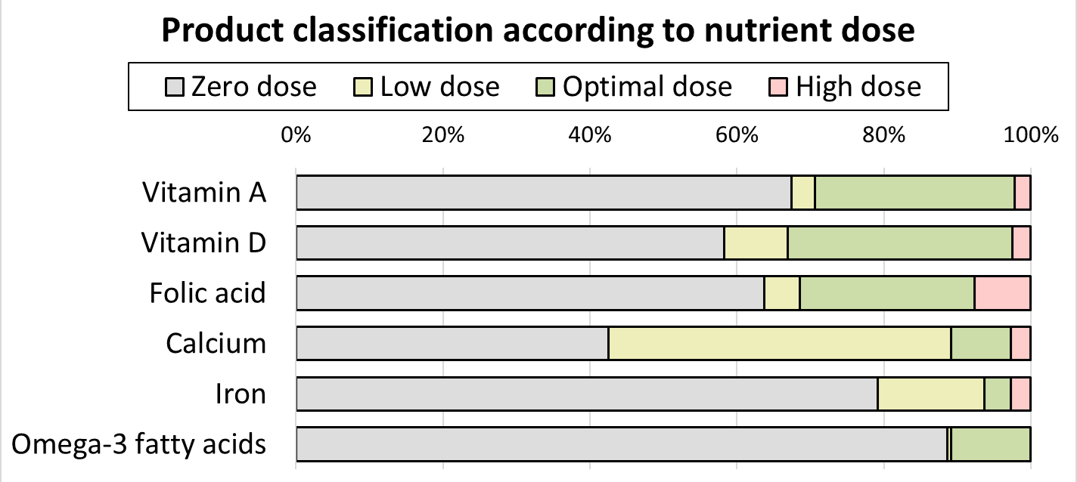

Supplementary Figure 5. Percent of prenatal dietary supplements in the NIH Dietary Supplement Label Database with zero, low, target, or high doses of key nutrients relative to recommendations for pregnancy (out of 421 unique prenatal products containing ≥1 key nutrient as of December 13, 2022).
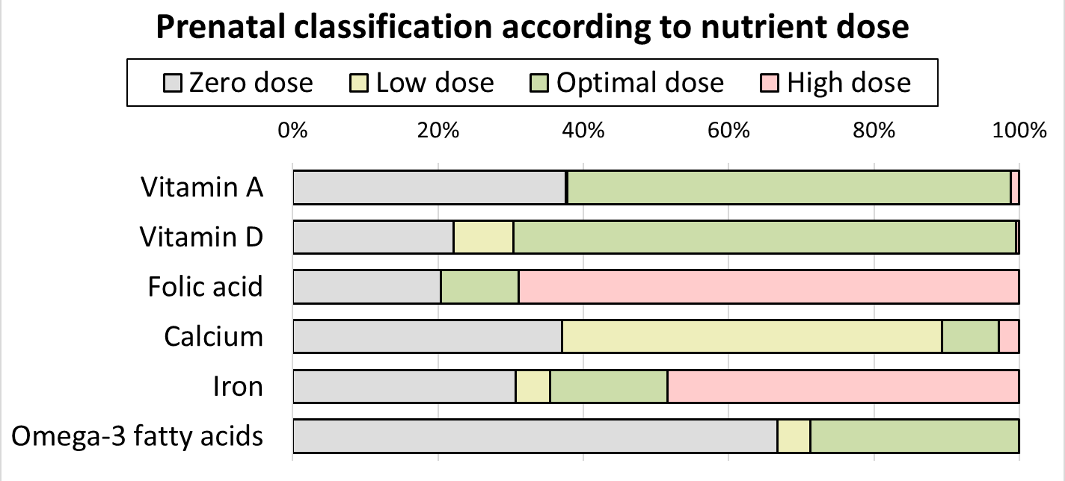

Supplementary Table 2. Nutrient content of highest ranked dietary supplements that are no longer on the market with the same formulation as recorded in the Dietary Supplement Label Database (as of December 13, 2022)
 |  | Vitamin A¹ |  | Vitamin D¹ | Folate¹ | Calcium | Iron | Omega-3 fatty | Market Status
 |  | Total  (mcg RAE) | Retinol  (mcg RAE) | (mcg) | (DFE mcg) | (mg) | (mg) | acids (mg)
Target supplementation² |  | ≥198 | ≤2063 | 7-91 | 169-720 | 383-943 | 13-22 | ≥59
Product (DSLD ID; input date)
 | Carlson Right 1 Daily  (54258; Dec 2015) | 1200 | 450 | 20 | 680 | 50 | 13.5 | 245 | Unavailable; may have been re-branded as Carlson Women’s Omega Multi (see details in manuscript Table 3)
 | GNC Women’s Prenatal Formula With DHA  (75159; Jun 2017) | 1350 | 0 | 10 | 1700 | 600 | 18 | 500 | Unavailable; may have been re-branded as GNC Women’s Multivitamin Prenatal Plus DHA & Iron (see details in manuscript Table 3)
 | Melaleuca Vitality 6 Essentials + Heart  (13664; Feb 2013) | 825 | 0 | 7.5 | 680 | 662.5 | 4.5 | 550 | Unavailable; no similar product available from manufacturer
 | NatureSmart Disney Princess Complete MultiVitamin  (26529; Oct 2013) | 1500 | 450 | 10 | 680 | 100 | 18 | 100 | Unavailable; no similar product available from manufacturer
 | NutriCology Super Immuno Complex  (183928; Nov 2018) | 2325 | 1209 | 7.5 | 200 | 385 | 8 | 600 | Unavailable; no similar product available from manufacturer
DFE, dietary folate equivalents; DHA, docosahexaenoic acid; DSLD, Dietary Supplement Label Database; EPA, eicosapentaenoic acid; RAE, retinol activity equivalents.
¹Conversions for alternate units reported on labels: vitamin A IU x 0.30 = vitamin A RAE; vitamin D IU x 0.025 = vitamin D mcg; folic acid mcg x 1.7 = folic acid mcg DFE. ⁹
²Defined as the range that results in ≤10% having intakes below the EAR (or 100 mg/day for omega-3 fatty acids) and ≤10% having intakes above the UL, based on the sample percentiles, for all participants aged 14-50 years.

Supplementary Table 3. Nutrient content of dietary supplements containing target levels of 5-6 key nutrients.
Yellow denotes ≥10% of women are at risk of inadequate intake at this dose; green denotes dose is on target for ≥80% of women; red denotes ≥10% of women are at risk of excessive intake at this dose. Asterisks denote products specifically marketed for pregnancy. Data obtained from the NIH Dietary Supplement Label Database on December 13, 2022.
 | Vitamin A¹ |  | Vitamin D¹ | Folate¹ | Calcium | Iron | Omega-3 fatty
 | Total (RAE) | Retinol (RAE) | (mcg) | (DFE mcg) | (mg) | (mg) | acids (mg)
Target supplementation² | ≥198 | ≤2063 | 7-91 | 169-720 | 383-943 | 13-22 | ≥99
Product (DSLD ID)
21st Century One Daily Women's (11561) | 750 | 600 | 20 | 667 | 450 | 18 | 0
21st Century Wellify! Women's Energy (207373) | 1500 | 1050 | 25 | 667 | 500 | 18 | 0
4 Today Primary Nutrition (33394) | 1500 | 1485 | 10 | 667 | 500 | 18 | 0
American Health More Than A Multiple Multivitamin For Women (81792) | 3000 | 0 | 10 | 667 | 500 | 18 | 0
American Health More Than A Multiple Multivitamin Formula (44421) | 3000 | 0 | 10 | 667 | 500 | 15 | 0
Basic Vitamins Women's Multivitamin Health Formula With Calcium & Extra Iron (11998) | 750 | 743 | 10 | 667 | 450 | 18 | 0
Bayer One A Day Women's 2O Mixed Berry Flavor (12230) | 750 | 600 | 20 | 667 | 450 | 18 | 0
Bayer One A Day Women's Women's Formula (178212) | 750 | 600 | 25 | 667 | 500 | 18 | 0
Bayer One A Day Women's Women's Petites (240456) | 700 | 630 | 25 | 665 | 400 | 18 | 0
Berkley Jensen Women's Daily (211344) | 750 | 600 | 25 | 667 | 500 | 18 | 0
BIOVEA Food Based Women's Multi (34746) | 3000 | 0 | 10 | 667 | 500 | 18 | 0
BIOVEA Women's Multi Food Based (207260) | 6000 | 0 | 10 | 666 | 500 | 18 | 0
Bronson Performance Edge (8794) | 3000 | 0 | 10 | 667 | 450 | 18 | 0
Carlson Right 1 Daily (54528) | 1200 | 450 | 20 | 667 | 50 | 14 | 245
Carlson Women's Omega Multi (216148) | 1200 | 444 | 20 | 667 | 50 | 14 | 245
Centrum Centrum Women Under 50 (18934) | 1050 | 746 | 20 | 667 | 500 | 18 | 0
CVS Pharmacy Daily Multiple For Women (25856) | 750 | 600 | 25 | 667 | 500 | 18 | 0
CVS Pharmacy Daily Multiple USP For Women (18196) | 750 | 600 | 25 | 667 | 500 | 18 | 0
DG Health Women's One Daily (82239) | 750 | 600 | 25 | 667 | 500 | 18 | 0
Douglas Laboratories Essential Female Pack (232997) | 1500 | 0 | 60 | 667 | 800 | 0 | 1000
Equaline One Daily Women's (7518) | 750 | 600 | 10 | 667 | 450 | 18 | 0
Equate One Daily Women's Health (208123) | 750 | 600 | 25 | 667 | 500 | 18 | 0
Family Wellness Women's One Daily (207170) | 750 | 600 | 25 | 667 | 500 | 18 | 0
GNC SuperFoods Ultra Mega Green Active Berry (78327) | 1500 | 1500 | 40 | 667 | 500 | 18 | 0
GNC WellBeing Be-Whole Multivitamin & Mineral With Iron & Iodine (19431) | 1500 | 750 | 40 | 667 | 500 | 18 | 0
GNC Women's Multivitamin Active (228926) | 1500 | 750 | 40 | 667 | 500 | 18 | 0
GNC Women's Multivitamin Diabetic Support (228906) | 1500 | 750 | 40 | 680 | 500 | 18 | 0
GNC Women's Multivitamin Energy & Metabolism (228979) | 1500 | 750 | 40 | 667 | 500 | 18 | 0
*GNC Women’s Multivitamin Prenatal Plus DHA & Iron (229141) | 1350 | 0 | 10 | 1700 | 600 | 18 | 500
GNC Women’s Multivitamin Ultra Mega (229009) | 1500 | 750 | 40 | 680 | 500 | 18 | 0
*GNC Women's Prenatal Formula With DHA (75159) | 1350 | 0 | 10 | 1667 | 600 | 18 | 500
GNC Women's Ultra Mega Active (74873) | 1500 | 750 | 40 | 667 | 500 | 18 | 0
GNC Women's Ultra Mega Active Chocolate (63367) | 1500 | 750 | 40 | 667 | 500 | 18 | 0
GNC Women's Ultra Mega Diabetic Support (74847) | 1500 | 750 | 40 | 667 | 500 | 18 | 0
GNC Women's Ultra Mega Energy & Metabolism (78522) | 1500 | 750 | 40 | 667 | 500 | 18 | 0
GNC Women's Ultra Mega Energy & Metabolism Chocolate (221095) | 1500 | 750 | 50 | 667 | 500 | 18 | 0
GNC Women's Ultra Mega Energy & Metabolism Vanilla (74777) | 1500 | 750 | 50 | 667 | 500 | 18 | 0
GNC Women's Ultra Mega Energy And Metabolism (12031) | 1500 | 750 | 40 | 667 | 500 | 18 | 0
GNC Women's Ultra Mega Heart (70131) | 1500 | 750 | 40 | 667 | 500 | 18 | 0
GNC Women's Ultra Mega Women's Ultra Mega (78531) | 1500 | 750 | 40 | 667 | 500 | 18 | 0
GNC Women's Ultra Mega Women's Ultra Mega With Probiotics (27806) | 1500 | 750 | 40 | 667 | 500 | 18 | 0
GoodSense Women's One Daily (72293) | 750 | 600 | 25 | 667 | 500 | 18 | 0
HIT Supplements Nutravive Multi-Vitamin (51169) | 750 | 750 | 20 | 667 | 450 | 18 | 0
Indiana Botanic Gardens Women's Daily Wellness With Iron (77322) | 750 | 675 | 25 | 667 | 500 | 18 | 0
Isagenix Ageless Essentials With Product B (62366) | 750 | 0 | 25 | 500 | 450 | 0 | 540
IVL Institute For Vibrant Living Food Based Women's Multi Comprehensive Formula (15433) | 3000 | 0 | 10 | 667 | 500 | 18 | 0
Kroger One Daily Women's Health (82110) | 750 | 600 | 25 | 667 | 500 | 18 | 0
Leader Women's Multivitamin (206021) | 750 | 600 | 25 | 667 | 500 | 18 | 0
Life Zone Basic Plus (3597) | 1500 | 750 | 10 | 667 | 500 | 18 | 0
Longs Wellness One Daily Women's With Calcium, Iron & Zinc (7798) | 750 | 600 | 10 | 667 | 450 | 18 | 0
Mason Natural Women's Daily Multi Formula (244782) | 710 | 568 | 25 | 667 | 500 | 18 | 0
Meijer OneDaily Women's (239856) | 750 | 600 | 25 | 667 | 500 | 18 | 0
Melaleuca Vitality 6 Essentials + Heart (13664) | 825 | 0 | 8 | 667 | 663 | 5 | 550
Metagenics Wellness Essentials Women's Prime (216515) | 1500 | 1485 | 48 | 665 | 410 | 0 | 1000
MET-Rx Arsenal Training Packs (34651) | 1500 | 1485 | 50 | 667 | 425 | 0 | 1120
Natrol My Favorite Multiple For Women (56187) | 1500 | 0 | 10 | 667 | 500 | 18 | 0
Nature Made Multi Daily (179576) | 900 | 900 | 10 | 667 | 450 | 18 | 0
Nature Made Multi Daily Essential Formula (8927) | 900 | 900 | 10 | 667 | 450 | 18 | 0
Nature's Bounty Multi-Day Women's (29190) | 750 | 600 | 25 | 667 | 500 | 18 | 0
Nature's Bounty Platinum High Potency Ultra Woman (60225) | 1500 | 1485 | 50 | 667 | 500 | 18 | 0
Nature's Way Alive! Women's Multivitamin (64589) | 1500 | 1050 | 25 | 667 | 500 | 18 | 0
NatureSmart Disney Princess Complete MultiVitamin (26529) | 1500 | 450 | 10 | 667 | 100 | 18 | 100
NutriCology Super Immuno Complex (183928) | 2325 | 1209 | 8 | 200 | 385 | 8 | 600
One A Day Women's One A Day (3174) | 750 | 750 | 10 | 667 | 450 | 18 | 0
One A Day Women's Women's Formula (239400) | 750 | 600 | 25 | 667 | 500 | 18 | 0
Optimox Corporation Gynovite Plus (32466) | 1500 | 1500 | 10 | 667 | 500 | 18 | 0
Optimox Gynovite Plus (236836) | 1500 | 1500 | 10 | 400 | 450 | 18 | 0
Precision Engineered Training Packs (71792) | 1500 | 1485 | 50 | 667 | 422 | 0 | 1120
ProCaps Laboratories Women's Complete with Maximum Essential Omega-3 1000 mg (220170) | 750 | 0 | 50 | 200 | 400 | 0 | 850
ProCaps Laboratories Women's Complete With Maximum Essential Omega-3 1000 mg (58676) | 1500 | 0 | 50 | 667 | 400 | 0 | 800
ProCaps Laboratories Women's Complete with Maximum Essential Omega-3 500 mg (220181) | 750 | 0 | 50 | 200 | 400 | 0 | 425
ProCaps Laboratories Women's Complete With Maximum Essential Omega-3 500 mg (58675) | 1500 | 0 | 50 | 667 | 400 | 0 | 400
ProCaps Laboratories Women's Elite 100 with Maximum Essential Omega-3 1000 mg (220674) | 750 | 0 | 50 | 200 | 400 | 0 | 850
ProCaps Laboratories Women's Elite 100 with Maximum Essential Omega-3 500 mg (220692) | 750 | 0 | 50 | 200 | 400 | 0 | 425
ProCaps Laboratories Women's Life Rx Elite Plus Maximum Essential Omega-3 (29945) | 1500 | 0 | 40 | 667 | 500 | 0 | 800
Pure Encapsulations Women's Pure Pack (183301) | 1125 | 0 | 38 | 667 | 500 | 0 | 500
Puritan's Pride Premium Ultra Woman Daily Multi (74222) | 1500 | 1485 | 50 | 667 | 500 | 18 | 0
Puritan's Pride Premium Women's Exclusive Formula Daily Multi (26668) | 1500 | 1485 | 10 | 667 | 500 | 15 | 0
Puritan's Pride Women's One Daily (26007) | 750 | 743 | 25 | 667 | 550 | 18 | 0
reliv Classic (218635) | 1570 | 1570 | 10 | 665 | 830 | 18 | 0
Rite Aid Pharmacy One Daily Women's with Vitamin D-3 (239747) | 750 | 600 | 25 | 667 | 500 | 18 | 0
Safeway Care One Daily Women's Formula (12207) | 750 | 600 | 25 | 667 | 500 | 18 | 0
Shaklee High Potency Vita-Lea Women (5000) | 1500 | 450 | 20 | 667 | 450 | 18 | 0
Shaklee Life with Iron (218568) | 1875 | 469 | 31 | 667 | 500 | 18 | 1000
Shaklee Life Without Iron (218577) | 1875 | 469 | 31 | 667 | 500 | 0 | 1000
Shaklee Vita-Lea Iron Formula (17519) | 1500 | 450 | 20 | 667 | 450 | 18 | 0
Shaklee Vitalizer (17332) | 1500 | 750 | 25 | 667 | 500 | 0 | 460
Shaklee Vitalizer Gold (218585) | 1875 | 469 | 30 | 667 | 500 | 0 | 460
Shaklee Vitalizer Gold Without Vitamin K (218594) | 1875 | 469 | 30 | 667 | 500 | 0 | 460
Shaklee Vitalizer Men (218620) | 1875 | 469 | 25 | 667 | 500 | 0 | 460
Simply Right Women's Complete Multivitamin (65889) | 1050 | 746 | 20 | 667 | 500 | 18 | 0
Smart Sense One Daily Women's Formula (82307) | 750 | 600 | 25 | 667 | 500 | 18 | 0
Top Care Century Ultimate Women's (38017) | 1050 | 746 | 20 | 667 | 500 | 18 | 0
up&up Women's Daily Multivitamin (209631) | 750 | 600 | 25 | 667 | 500 | 18 | 0
Vitamin World Ultra Woman (67650) | 1500 | 1485 | 50 | 667 | 500 | 18 | 0
Vitamin World Ultra Woman Daily Multi (65674) | 1500 | 1485 | 50 | 667 | 500 | 18 | 0
Viva Vitamins VegiSource Multivitamin (20021) | 3000 | 0 | 10 | 667 | 600 | 18 | 0
Wachters' No. 200 Futura 200 (22226) | 5400 | 0 | 10 | 667 | 500 | 18 | 0
Walgreens One Daily Multivitamin Women's (239899) | 750 | 750 | 25 | 667 | 500 | 18 | 0
Well At Walgreens Multivitamin Women (60898) | 1050 | 746 | 20 | 667 | 500 | 18 | 0

DFE, dietary folate equivalents; DSLD, Dietary Supplement Label Database; RAE, retinol activity equivalents
¹Conversions for alternate units reported on labels: vitamin A IU x 0.30 = vitamin A RAE; vitamin D IU x 0.025 = vitamin D mcg; folic acid mcg x 1.7 = folic acid mcg DFE.⁹
²Defined as the range that results in ≤10% having intakes below the EAR (or 100 mg/day for omega-3 fatty acids) and ≤10% having intakes above the UL, based on the sample percentiles, for all participants aged 14-50 years.

References
1. Shapiro ALB, Kaar JL, Crume TL, et al. Maternal diet quality in pregnancy and neonatal adiposity: the Healthy Start Study. Int J Obesity. 2016;40(7):1056-1062.
2. Subar AF, Kirkpatrick SI, Mittl B, et al. The Automated Self-Administered 24-hour dietary recall (ASA24): a resource for researchers, clinicians, and educators from the National Cancer Institute. Journal of the Academy of Nutrition and Dietetics. 2012;112(8):1134-1137.
3. Bastain TM, Chavez T, Habre R, et al. Study Design, Protocol and Profile of the Maternal And Developmental Risks from Environmental and Social Stressors (MADRES) Pregnancy Cohort: a Prospective Cohort Study in Predominantly Low-Income Hispanic Women in Urban Los Angeles. BMC Pregnancy Childbirth. 2019;19(1):189.
4. Ma T, Bu S, Paneth N, Kerver JM, Comstock SS. Vitamin D Supplementation in Exclusively Breastfed Infants Is Associated with Alterations in the Fecal Microbiome. Nutrients. 2022;14(1).
5. O'Connor T, Best M, Brunner J, et al. Cohort profile: Understanding Pregnancy Signals and Infant Development (UPSIDE): a pregnancy cohort study on prenatal exposure mechanisms for child health. BMJ Open. 2021;11(4):e044798.
6. USDA Food and Nutrient Database for Dietary Studies, 4.1. Beltsville, MD: Agricultural Research Service, Food Surveys Research Group; 2010.
7. Ferranti EP, Hartman TJ, Elliott AJ, et al. Diet Quality of Pregnant American Indian Women in the Northern Plains. Prev Chronic Dis. 2019;16:E53.
8. Kipnis V, Midthune D, Buckman DW, et al. Modeling data with excess zeros and measurement error: application to evaluating relationships between episodically consumed foods and health outcomes. Biometrics. 2009;65:1003-1010.
9. US Department of Health and Human Services, Food and Drug Administration, Center for Food Safety and Applied Nutrition. Converting Units of Measure for Folate, Niacin, and Vitamins A, D, and E on the Nutrition and Supplement Facts Labels: Guidance for Industry. In: Administration FaD, ed. College Park, MD2019.

